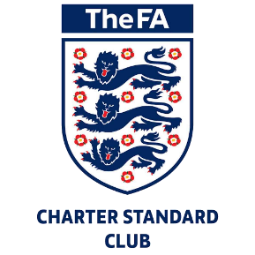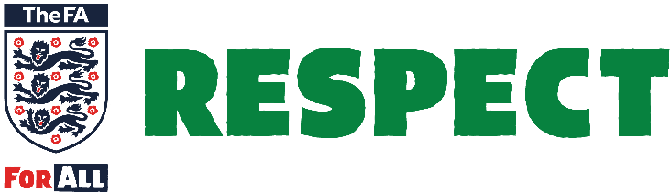

Respect Code of Conduct

Spectators and Parents/Carers

We all have a responsibility to promote high standards of behaviour in the game

This club is supporting The FA’s Respect programme to ensure football can be enjoyed in a safe, positive environment.

Remember children’s football is a time for them to develop their technical, physical, tactical and social skills. Winning isn’t everything.

Play your part and always observe The FA’s Respect Code of Conduct for spectators and parents/carers.

I will:

* Remember that children play for FUN
* Applaud effort and good play as well as success
* Always respect the match officials’ decisions
* Remain outside the field of play and within
* the Designated Spectators’ Area (where provided)
* Let the coach do their job and not confuse the players by telling them what to do
* Encourage the players to respect the opposition, referee and match officials
* Avoid criticising a player for making a mistake – mistakes are part of learning
* Never engage in, or tolerate, offensive, insulting, or abusive language or behaviour.

I understand that if I do not follow the Code, any/all of the following actions may be taken by my club, County FA, league or The FA:

I may be:

* Issued with a verbal warning from a club or league official
* Required to meet with the club, league or County FA Welfare Officer
* Required to meet with the club committee
* Obliged to undertake an FA education course
* Obliged to leave the match venue by the club
* Requested by the club not to attend future games
* Suspended or have my club membership removed
* Required to leave the club along with any dependents.

In addition:

* The FA/County FA could impose a fine and/or suspension on the club.